**Employee Performance Alignment and Evaluation System**

Employee Name: Rochell Mark A. Mananggit Position: Font end Developer

Immediate Superior: Rommel Villanueva                 Department:

Review Period:                                         Date: November 13, 2023

***Instructions:*** *Rate the employee's performance during the review period by checking the most appropriate numerical value in each section. To determine the overall performance rating, add the numerical values together and divide by eight (or 11 if the supervisor section was completed). Prior to the performance discussion with the employee, a detailed plan to address areas rated "needs improvement" or "unacceptable" must be submitted to the department head and human resources for review.*

**Rating scale:**

 5   Excellent (consistently exceeds standards)

 4   Outstanding (frequently exceeds standards)

 3   Satisfactory (generally meets standards)

 2   Needs improvement (frequently fails to meet standards)

 1   Unacceptable (fails to meet standards)

|  |  |  |  |  |  |
| --- | --- | --- | --- | --- | --- |
| **​** | **​5** | **​4** | **​3** | **​2** | **​1** |
| **Job knowledge**  Knowledge of products, policies, and procedures; OR knowledge of techniques, skills, equipment, procedures, and materials. |  | X |  |  |  |
| **Quality of work**  Freedom from errors and mistakes. Accuracy, quality of work in general. |  |  | X |  |  |
| **Quantity of work**  Productivity of the employee. |  |  | X |  |  |
| **Reliability**  The extent to which the employee can be depended upon to be available for work, to complete work properly, and complete work on time. The degree to which the employee is reliable, trustworthy, and persistent. |  |  | X |  |  |
| **Initiative and creativity**  The ability to plan work and to proceed with a task without being told every detail and the ability to make constructive suggestions. |  |  | X |  |  |
| **Judgment**  The extent to which the employee makes decisions that are sound. The ability to base decisions on fact rather than emotion. |  |  | X |  |  |
| **Cooperation**  Willingness to work harmoniously with others in getting a job done. Readiness to respond positively to instructions and procedures. |  | X |  |  |  |
| **Attendance**  Consistency in coming to work daily and conforming to scheduled work hours. |  |  | X |  |  |

**Complete this section for employees with supervisory/team leadership responsibilities:**

|  |  |  |  |  |  |
| --- | --- | --- | --- | --- | --- |
| **​** | **​5** | **​4** | **​3** | **​2** | **​1** |
| **Planning and organizing**  The ability to analyze work, set goals, develop plans of action, utilize time. Consider the amount of supervision required and the extent to which you can trust employees to carry out assignments conscientiously. | X |  |  |  |  |
| **Directing and controlling**  The ability to create a motivating climate, achieve teamwork, train and develop, measure work in progress, and take corrective action. | X |  |  |  |  |
| **Decision-making**  The ability to make decisions and the quality and timeliness of those decisions. | X |  |  |  |  |

Noteworthy accomplishments during this review period:

Fixing bugs and create emans from scratch.

Areas requiring improvement in job performance (attach the performance improvement plan for any areas rated needs improvement or unacceptable):

Productivity

Actions taken to improve performance from the previous review:

Study and apply the learnings to become a better employee.

Professional development goals:

To become reliable and expert in my field.

*Add all numerical values from each category then divide by 8 (or 11 if the supervisor section was completed).*

**Overall performance rating:  _____**

Employee comments:

______________________________________________________________________

______________________________________________________________________

______________________________________________________________________

______________________________________________________________________

Signatures acknowledge that this form was discussed and reviewed.

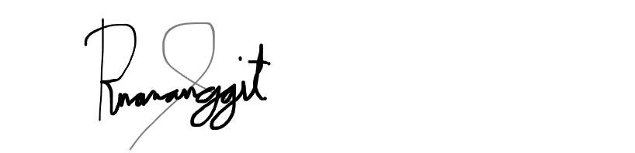

Employee signature:                                                           Date: November 13, 2023

Supervisor signature:                                                       Date: